USER EXPERIENCE TESTING

**Techart Trekkies**

| **Submitted By:** | **Submitted To:** |
| --- | --- |
| **Nischal Shrestha** | **Prajesh Shakya** |

**Date: 7th April, 2025**

# ABSTRACT

This report summarizes what I learnt from a user experience (UX) testing study conducted on the **Techart Trekkies** website. The study aimed to evaluate the website’s usability, accessibility, and overall user satisfaction. The results highlighted key areas of strength and identified critical usability issues, including navigation complexities. Recommendations are provided to address the issues, focusing on improving the website’s efficiency, intuitiveness, and user engagement. Ultimately, this report aims to inform the optimization of the **Techart Trekkies** website, ensuring a more positive and effective user experience.

# Techart Trekkies

## Homepage: Solutions

When pressing any of the solutions in the Solutions section in the Homepage, the system redirects the user to the “Services” page which is fine by itself.

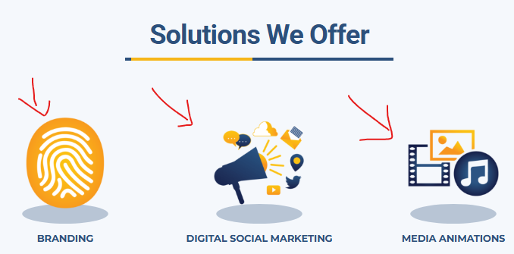

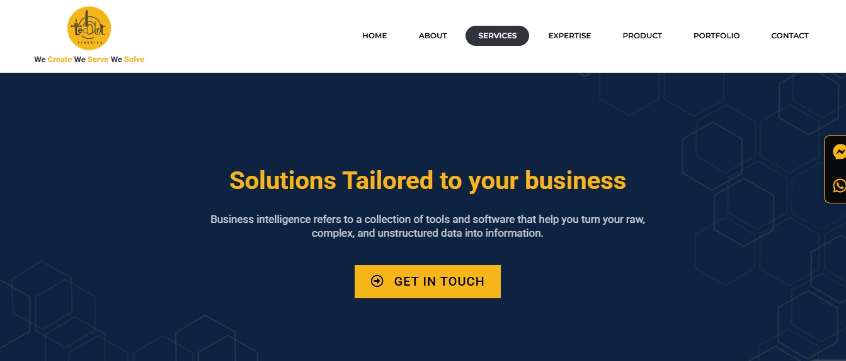

But it would be better if the system could directly redirect the user to the specific article or item they pressed in the homepage.

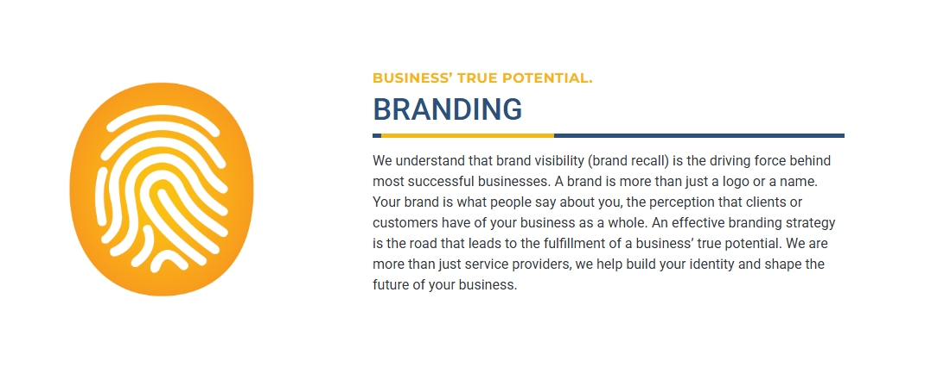

**Homepage: Trusted by Brands**

There are logos of the brands and institutions who trust **Techart Trekkies** in the Brand section of the Homepage which is fine by itself. But adding a link of each brand or institution's website to their respective logos would be the cherry on top of the cake in the user experience field.



**Product: Impexo & Imagine**

Below the description of both products; Impexo & Imagine, there are “App” and “Website” links. The “Website” link redirects the end-user to the respective product’s website but the “App” link redirects the user to the “Login” page of the respective product when it should redirect the user to the product's app details.

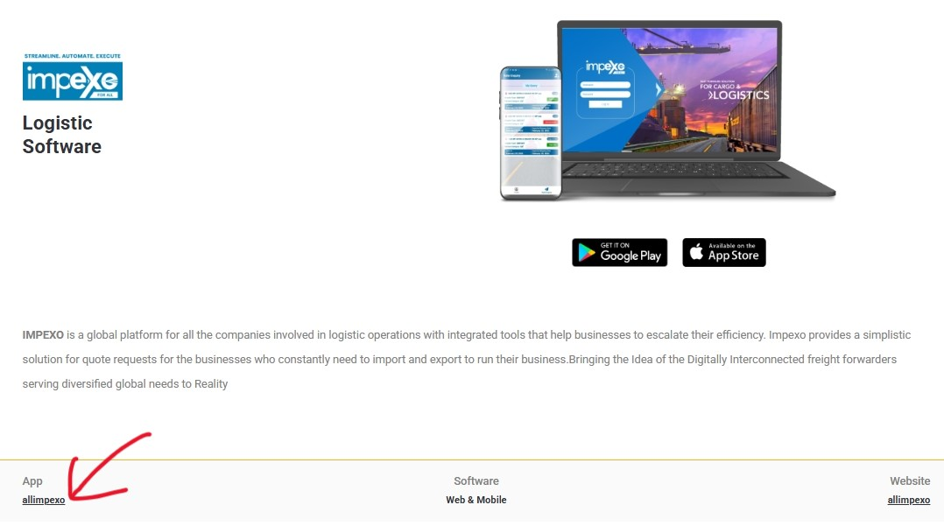

**Portfolio**

All of the tablist items; “Website”, “Social Media Post”, “Creative Campaigns”, “Graphic Designs” & “ECommerce” have a view button on the bottom left of each item card.

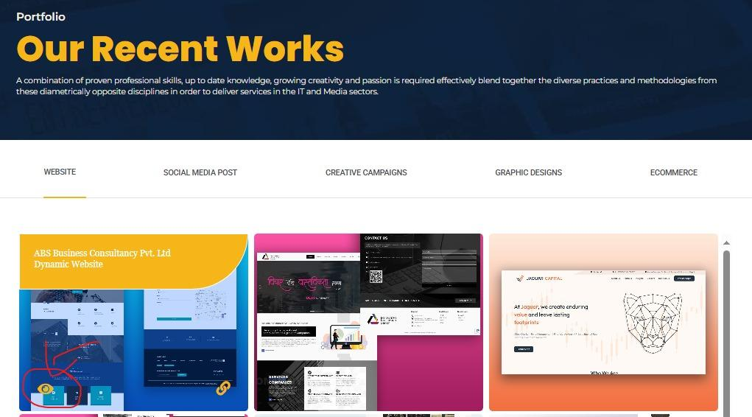

When clicked, the view button displays the respective items UI in a small pop up box which is very good. However, if the pop up box also contained the title and description of the item’s website, it could enhance the user experience by a lot.

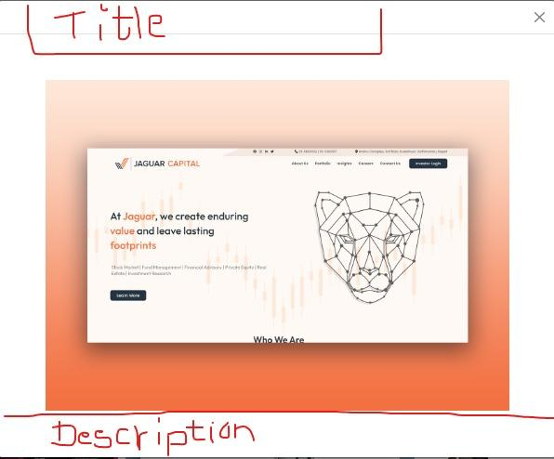

## Portfolio: Website - Nassar Overseas Pvt. Ltd

The link button in Nassar Overseas website’s redirects the end-user to Techart Trekkies page instead of its own website.

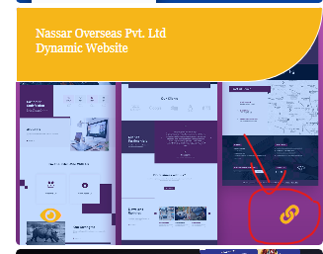

*If the website of this organization is not functioning anymore, removing the item from the Website tablist would be more optimal.*

## Portfolio: Social Media Post - Impexo Festive Design

The viewed item and item seen when we click the link does not match. It is a completely different project or design.

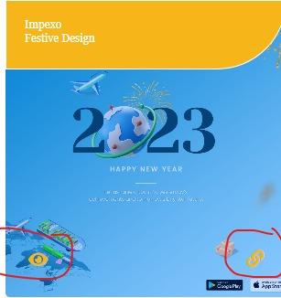

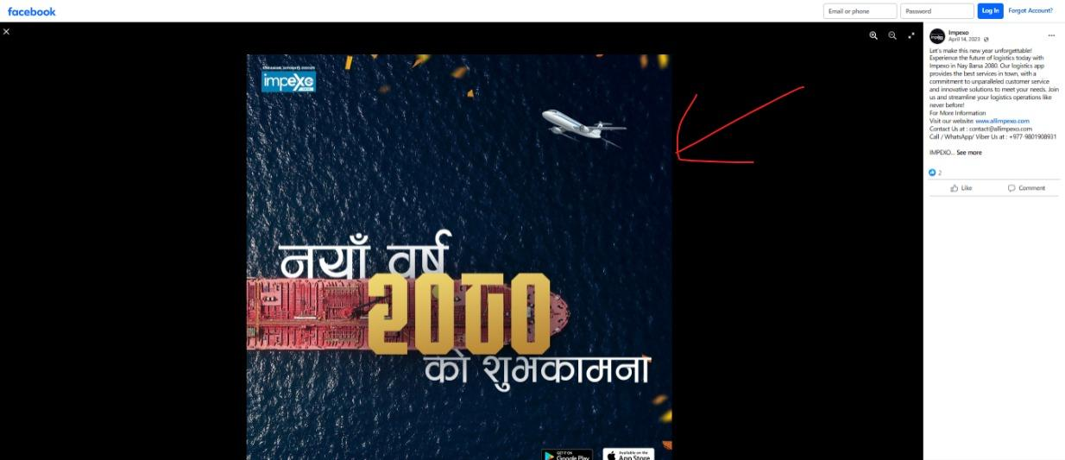

*If the design has been changed or updated, the view in the Techart Trekkies website should also be done simultaneously to remove any kind of confusion for the end-user.*

## Portfolio: Social Media Post - Imagine Inquiry SYS Festive Design

The viewed item and item seen when we click the link does not match. It is a completely different project or design.

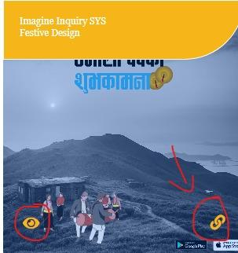

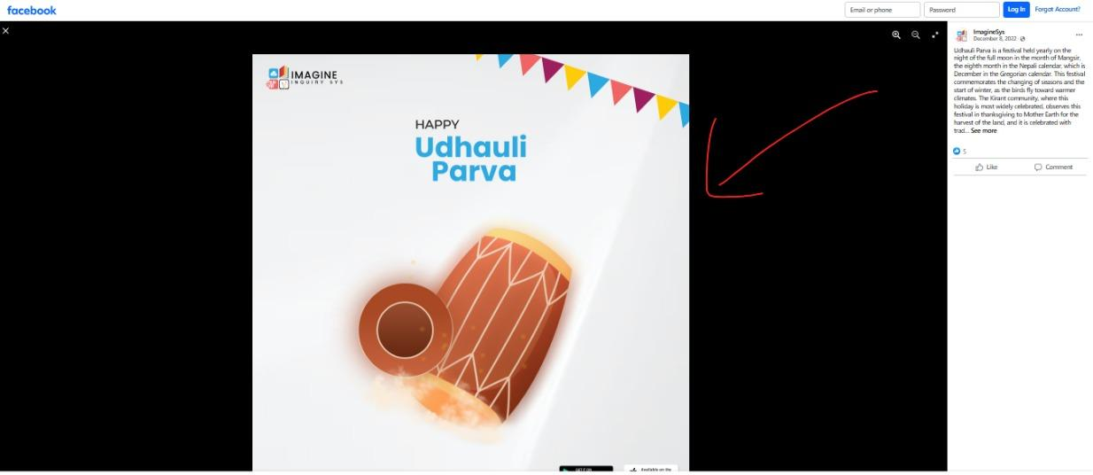

*If the design has been changed or updated, the view in the Techart Trekkies website should also be done simultaneously to remove any kind of confusion for the end-user.*

## Contact

The background for “Contact Us” looks too bland in comparison to the rest of the website’s UI designs.

